Plattsburgh, February 28th, 2014.
Dear Deputy Commissioner Slentz and Regent Dawson:
I represent a parents group called North Country Alliance for Public Education (NCAPE), which is also a member of a much larger group consisting of 45 parents groups from all over New York (NYSAPE). We learned that you were visiting Plattsburgh and meeting with our region's superintendents, so we are taking this opportunity to write this letter to you to voice some of our concerns with the current situation of education in our State.
We are parents who are very alarmed and troubled by the damage to our children, teachers, schools, and local districts caused by the Common Core. For us, the parents, it started with our children's confusion and frustration with the amount of testing that they were asked to do. Many of our children cry in the morning and don't want to go to school because of the ridiculous and stressful circumstances sanctioned by adults on their behalf. Some get sick when they have a test. Some are starting to think that "school and learning are not their thing."
Our schools are dedicating less and less time to history, geography, music, art, foreign languages, field trips... Our teachers are stopping activities that are creative, formative, and fun for the kids, because they are drowning with the amount of required paperwork, "data" collection, and the climate of mistrust implied by these measures. Experienced and well respected teachers must now "prove" to data collectors what they have long established to their true constituents: students, parents, administrators, and local public. Teachers are also quite concerned about their evaluations, since a large percentage of them is tied to the children's scores on standardized testing (again, with no evidence that this is a valid measure) and since many teachers (if not all) may get their final score from their school's scores. This situation is even more troubling with the realization that none of these measures have been field tested or adequately researched before being mandated. The students and teachers have been made the unwitting guinea pigs for the state's ill-considered plans.
Parents all over the State of New York, as well as nationally, have started a vigorous conversation about these issues, mostly because they have sought to fill the deficit of leadership by state educational administrators. Heartbreaking stories and outrageous examples of scripted lessons through "modules" and inadequate homework from a developmental point of view, are being shared through public media. In the past we did not need to look at the ways in which our schools were doing their job. In the past we just had to be sure that we were good partners with our children's teachers and that between all of us, we would help our children to learn as much as possible and develop a love for learning and a capacity and willingness to shoulder the responsibilities of active citizenship in public life.
The pain and frustration brought to our families and communities from the Common Core (and its mangled implementation), has forced parents to investigate, and we strongly disliked what we found. This is an untested curriculum assembled and promulgated by those with little educational background and questionable motives, which contains severely flawed and inaccurate materials and lacks matter appropriate for children with special needs.
It has become obvious to most of us that there is a strong effort guided by politicians and corporations to discredit American public schools, to make them look bad and to "justify" their closure and posterior re-opening as private schools (aka Charter). We also were astonished when we learned that the State Education Department of New York was sharing our children's personal data without our knowledge or approval. And we are flabbergasted about the amount of money that our schools have to pay to cover for constant costs associated with teachers and administrators' training, test applications, and NEW materials to fatten corporate wallets. Through the imposition of the Federal program Race To The Top, enormous financial burdens and distress are brought to our children, teachers and taxpayers. Most schools accepted this program believing that it would aid funding. Instead, school coffers have been drained to buy confusion, frustration, anxiety, and reduced local control.
This spring many parents will refuse the New York 3 through 8 Tests. This is an organized civil disobedience movement that intends to reach State Education Department leaders and legislators to let you know that the current situation is NOT working and that we, parents, voters and taxpayers are very concerned about the future of public education for all.
This is civil disobedience to a system that favors corporate profits and state and federal control over the welfare of public schools, its teachers, localities, and most importantly, its children. Children need to be respected, well treated, and provided with the tools to become responsible and implicated citizens in a democratic country, and not made dupes of self-serving bureaucracies.
We respectfully ask that you listen to this cry. We ask that you return to doing what public education has always done. We ask that you stop the politics and the profiteering of a few and start acknowledging the real problems that our schools are facing. We ask that you stop threatening teachers and schools with consequences based on their parents’ actions who are, in the end, the primary and true advocates of children. We request that all children whose parents decide to refuse the exams be treated respectfully, not asked to do anything else (the parents' letters should suffice and they should not be asked to refuse the test) and given an alternative activity such as individual reading, with which to engage while their classmates complete the exams.
We hope you that you will share this letter with Commissioner King, Chancelor Tisch and the rest of the Regents, as a written complaint by parents about Common Core: an educational curriculum that is harming kids as well as democratic American expectations.
We hope that you and your colleagues will take our requests and this civil disobedience movement seriously and that very soon you will begin to exert you considerable influence to remedy this failed and misguided program. Please remove our teachers' evaluations from standardized exams' results. Please let the teachers, the true teachers, be in charge of education improvements: let them do what they do best.
Respectfully,
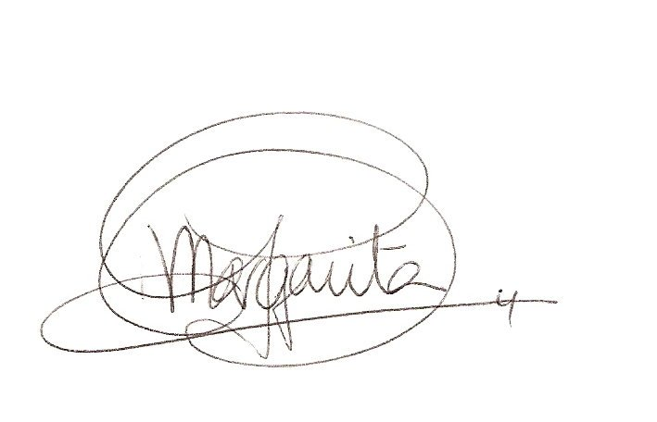
Margarita Garcia-Notario, PhD.

Co-founder of the North Country Alliance for Public Education.
Member of the New York State Allies for Public Education.

